PROJECT REPORT
“ATM MACHINE”
NAME: YANA PARASHAR

CLASS: XII – C

SUBJECT: COMPUTERSCIENCE

CERTIFICATE

This is to certify that student Yana Parashar has successfully completed the project Work entitled ATM MACHINE in the subject Computer Science (083) laid down in the regulations of CBSE for the purpose of Practical Examination in Class XII
SERIAL NO. | DESCRIPTION | PAGE NO.
1. | ACKNOWLEDGEMENT | 2
2. | ITRODUCTION | 3
3. | OBJECTIVE OF PROJECT | 4
4. | PROPOSED SYSTEM
5. | SYSTEM DEVELOPMENT LIFE CYCLE
6. | PHASES OF LIFE CYCLE
7. | FLOW CHART
8. | SOURCE CODE FOR SQL
9. | OUTPUT
10. | TESTING
11. | HARDWARE & SOFTWARE REQUIREMENTS
12 | INSTALLATION PROCEDURES
13. | BIBLIOGRAPHY

ACKNOWLEDGEMENT
Apart from the efforts of me, the success of any project depends largely on the encouragement and guidelines of teachers. I take this opportunity to express my gratitude to the teacher who have been instrumental in the successful completion of this project. I express my heartfelt gratitude to my parents for constant encouragement while carrying out this project.The guidance and support received from all the members who contributed and who are contributing to this project, was vital for the success of the project. I am grateful for their constant support and help.

INTRODUCTION

An automated teller machine (ATM) is an electronic telecommunications device that enables customers of financial institutions to perform financial transactions, such as cash withdrawals, deposits, funds transfers, or account information inquiries, at any time and without the need for direct interaction with bank staff.

Types of ATMs
There are two primary types of ATMs. Basic units only allow customers to withdraw cash and receive updated account balances. The more complex machines accept deposits, facilitate line-of-credit payments and transfers, and access account information.
To access the advanced features of the complex units, a user must be an account holder at the bank that operates the machine.
Analysts anticipate ATMs will become even more popular and forecast an increase in the number of ATM withdrawals. ATMs of the future are likely to be full-service terminals instead of or in addition to traditional bank tellers.

SOME ATM FUCNCTIONS INCLUDES :
OBJECTIVE:
- INPUT USER PIN FOR AUTHENTICATIOn
- DEPOSIT FUNDS
- CHECK ACCOUNT BALANCE
- WITHDRAW FUNDS
- CREATE RANDOM TRANSACTION ID
- ACCOUNT INTEREST RATE
- MONTHLY ACCOUNT INTEREST RATE
. Proposed System:

The system customer transactions, satisfies the requirements of the existing system in full-fledged manner. Through this system, customer can make fast transactions and view the last transactions easily.

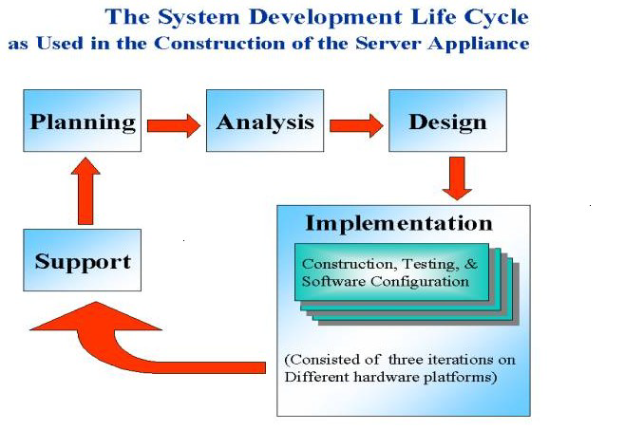
System Analysis:
Understand the problem before the system to create analysis model there is a tendency to rush to a solution, even before the problem is understood.Develop prototypes that enables user to understand how human/machine interaction will occur. Since the perception of the quality of software is often based on the perception of the “friendliness” of the interface prototyping is highly recommended.Record the origin of and the reason for every requirement. This is the first step-in establishing traceability back to the customer.Use multiple views of requirements building data, functional and behavioral models provide the software engineer with three different views. This reduces the likelihood that something will be missed and increases the likelihood that inconsistency will be recognized.Rank requirements. Tight deadlines may preclude the implementation of every software requirements to be delivered in the first increment must be identified.Work to eliminate ambiguity because most requirements are described in a natural language, the opportunity for ambiguity abounds.
System planning:
Analysis principles are applied and a model of the software to be build called a planning (prototype) is constructed for customer and developer assessment.The close-ended approach is often called throwaway prototyping using this approach a prototype serves solely as a rough demonstration of requirements it is then discarded and the software is engineered using a different paradigm An open-ended approach, called evolutionary prototyping uses the prototype as the first part of an analysis activity that will be continued into design and construction the prototype of the software is the first evolution of the finished system.
SYSTEM CONCEPT DEVELOPMENT PHASE
The System Concept Development Phase begins after a business need or opportunity is validated by the Agency/Organization Program Leadership and the Agency/Organization CIO.
The purpose of the System Concept Development Phase is to:

- Determine the feasibility and appropriateness of the alternatives.
- Identify system interfaces.
- Identify basic functional and data requirements to satisfy the business need.
- Establish system boundaries; identify goals, objectives, critical success factors, and performance measures.
- Evaluate costs and benefits of alternative approaches to satisfy the basic functional requirements
- Assess project risks
- Identify and initiate risk mitigation actions, and Develop high-level technical architecture, process models, data models, and a concept of operations. This phase explores potential technical solutions within the context of the business need.
- It may include several trade-off decisions such as the decision to use COTS software products as opposed to developing custom software or reusing software components, or the decision to use an incremental delivery versus a complete, onetime deployment.
- Construction of executable prototypes is encouraged to evaluate technology to support the business process. The System Boundary Document serves as an important reference document to support the Information Technology Project Request (ITPR) process.
- The ITPR must be approved by the State CIO before the project can move forward.
PICTORIAL REPRESENTATION OF SDLC:

PHASES OF LIFE CYCLE

Stage-1: Planning And Requirement Analysis:
Planning is the crucial step in everything and so as in software development. In this same stage, requirement analysis is also performed by the developers of the organization. This is attained from the inputs from the customers, sales department/market surveys.
The information from this analysis forms the building block of a basic project. The quality proof of the project is a result of planning. Thus, in this stage, the basic project is designed with all the available information.
- Stage-2: Defining Requirements:
In this stage, all the requirements for the target software are specified. These requirements get approval from the customers, market analysts, and stakeholders.
This is fulfilled by utilizing SRS (Software Requirement Specification). This is a sort of a document that specifies all those things that need to be defined and created during the entire project cycle.

- Stage-3: Designing Architecture:
SRS is a reference for software designers to come out with the best architecture for the software. Hence, with the requirements defined in SRS, multiple designs for the product architecture are present in the Design Document Specification (DDS).
This DDS is assessed by market analysts and stakeholders. After evaluating all the possible factors, the most practical and logical design is chosen for the development.

- Stage-4: Developing Product:
At this stage, the fundamental development of the product starts. For this, developers use a specific programming code as per the design in the DDS. Hence, it is important for the coders to follow the protocols set by the association. Conventional programming tools like compilers, interpreters, debuggers, etc. are also put into use at this stage.

FLOW CHART :
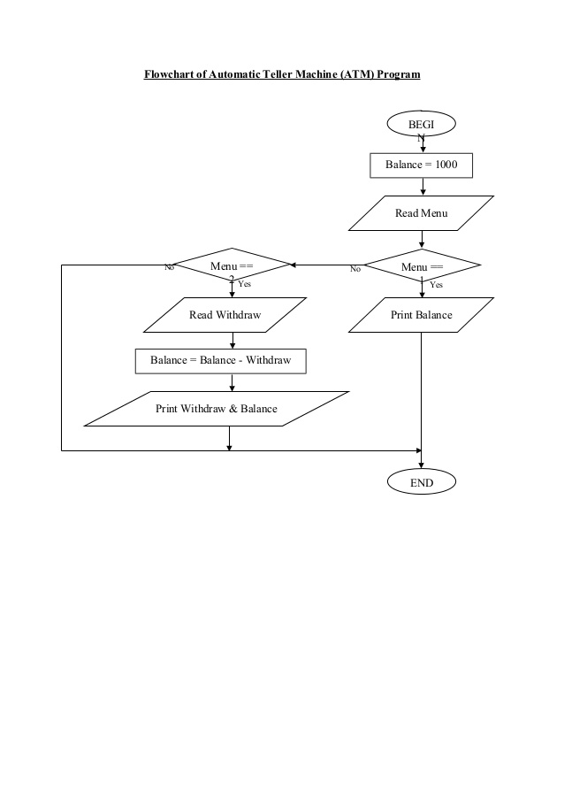

SOURCE CODE FOR SQL:
import mysql.connector as sql
conn=sql.connect(host='localhost',user='root',password='manager',database=' ATM_MACHINE')
c1=conn.cursor()
print("================================================================================")

print(" WELCOME TO OUR BANK ")

print("================================================================================")

print("1.To create account")
print("2.To login")
print("3.Exit")
print("================================================================================")

op=int(input("Enter your choice :"))
print("================================================================================")

if op==1:
c="y"
while c=="y":
m=int(input("Enter a 4 digit number as accont number:"))
cb="select * from records where ACCONT_NO={}".format(m)
c1.execute(cb)
d=c1.fetchall()
data=c1.rowcount
if data==1:
print("================================================================================")

print("This account number already exists:")
c=input("Do you want to continue y/n -")
print("================================================================================")

if c=="y":
continue
else:
print("Thank you.")
print("Visit again")
print("================================================================================")

else:
name=input("Enter your name:")
passw=int(input("Enter your pass word:"))
ab="insert into records(ACCONT_NO,PASSWORD,NAME) values({},{},'{}')".format(m,passw,name)
print("================================================================================")

c1.execute(ab)
conn.commit()
print("Account sucessfully created")
print("The minimum balance is 1000 ")
print("================================================================================")

s=int(input("Enter the money to be deposited :"))
print("================================================================================")

sr="update records set CR_AMT={} where ACCONT_NO={}".format(s,m)
c1.execute(sr)
conn.commit()
ef="update records set balance=cr_amt-withdrawl where ACCONT_NO={}".format(m)
c1.execute(ef)
conn.commit()
print("sucessfully deposited")

print("Thank you")
print("Visit again")
break
if op==2:
y="y"
while y=="y":
acct=int(input("Enter your account number:"))
cb="select * from records where ACCONT_NO={}".format(acct)
c1.execute(cb)
c1.fetchall()
data=c1.rowcount
if data==1:
pas=int(input("Enter your password :"))
print("================================================================================")

e="select password from records where ACCONT_NO={}".format(acct)
c1.execute(e)
a=c1.fetchone()
d=list(a)
if pas==d[0]:
print("correct")
print("1.Depositng money")
print("2.withdrawing money")
print("3.Transfering money")
print("4.Checking balance")
print("5.Changing Account number ")
print("================================================================================")

r=int(input("Enter your choice:"))
print("================================================================================")

if r==1:
amt=int(input("Enter the money to be deposited:"))
print("================================================================================")

sr="update records set CR_AMT=CR_AMT + {} where ACCONT_NO={}".format(amt,acct)
c1.execute(sr)
conn.commit()
ef="update records set balance=cr_amt-withdrawl where ACCONT_NO={}".format(acct)
c1.execute(ef)
conn.commit()
print("sucessfully deposited")
t=input("Do you want to continue y/n -")
print("================================================================================")

if t=="y":
continue
else:
print("Thank you")
if r==2:
amt=int(input("Enter the money to withdraw:"))
print("================================================================================")

ah="select BALANCE from records where accont_no={}".format(acct)
c1.execute(ah)
m=c1.fetchone()
if amt >m[0]:
print("Your are having less than",amt)
print("Please try again")
print("================================================================================")

else:
sr="update records set balance=balance - {} where ACCONT_NO={}".format(amt,acct)
ed="update records set WITHDRAWL ={} where ACCONT_NO={}".format(amt,acct)
c1.execute(ed)
c1.execute(sr)
conn.commit()
print("Sucessfully updatad")
y=input("do you want to continue y/n -")
if y=="y":
continue
else:
print("Thank you")
if r==3:
act=int(input("Enter the accont number to be transferrsd :"))

print("================================================================================")

cb="select * from records where ACCONT_NO={}".format(act)
c1.execute(cb)
c1.fetchall()
data=c1.rowcount
if data==1:
print(act ,"number exists")
m=int(input("Enter the money to be transferred :"))

print("================================================================================")

ah="select BALANCE from records where accont_no={}".format(acct)
c1.execute(ah)
c=c1.fetchone()
if m > c[0]:
print("Your are having less than",m)
print("Please try again")

print("================================================================================")

else:
av="update records set balance=balance-{} where ACCONT_NO={}".format(m,acct)
cv="update records set balance=balance+{} where ACCONT_NO={}".format(m,act)
w="update records set withdrawl=withdrawl+{} where accont_no={}".format(m,acct)
t="update records set CR_AMT=CR_AMT+{} where accont_no={}".format(m,act)
c1.execute(av)
c1.execute(cv)
c1.execute(w)
c1.execute(t)
conn.commit()
print("Sucessfully transfered")
y=input("do you want to continue y/n -")
if y=="y":
continue
else:
print("Thank you")
if r==4:
ma="select balance from records where accont_no={}".format(acct)
c1.execute(ma)
k=c1.fetchone()
print("Balance in your account=",k)
print("================================================================================")

y=input("do you want to continue y/n -")
if y=="y":
continue
else:
print("Thank you")
if r==5:
i=int(input("Enter your new account number:"))
cb="select * from records where ACCONT_NO={}".format(i)
c1.execute(cb)
c1.fetchall()
data=c1.rowcount
if data==1:
print("This number already exists")
print("Try again")

y=input("do you want to continue y/n -")
if y=="y":
continue
else:
print("Thank you")
else:
name=input("Enter your name")
ar="Update records set accont_no={} where name='{}' and password={}".format(i,name,pas)
c1.execute(ar)
conn.commit()
print("Your new account number is ",i)
else:
print("Wrong password")
print("================================================================================")

y=input("do you want to continue y/n -")
else:
print("your Account does not exists")

if op==3:
print("Exiting")
c1.close()

Python and MYSQL connection table creation

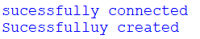
OUTPUT: ATM Project Output Is Displayed.

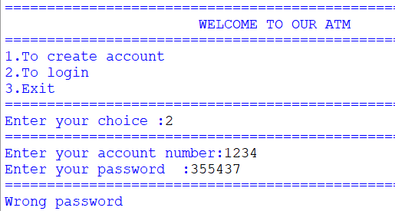
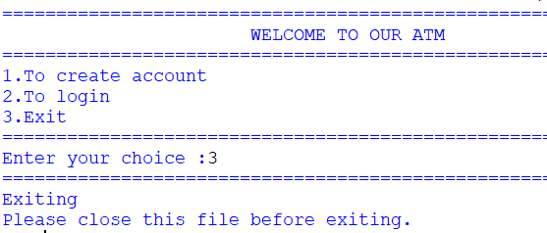
TESTING:
Software Testing is an empirical investigation conducted to provide stakeholders with information about the quality of the product or service under test[1] , with respect to the context in which it is intended to operate. Software Testing also provides an objective, independent view of the software to allow the business to appreciate and understand the risks at implementation of the software. Test techniques include, but are not limited to, the process of executing a program or application with the intent of finding software bugs.
ESTING METHODS
Software testing methods are traditionally divided into black box testing and white box testing. These two approaches are used to describe the point of view that a test engineer takes when designing test cases.

BLACK BOX TESTING
Black box testing treats the software as a "black box," without any knowledge of internal implementation. Black box testing methods include: equivalence partitioning, boundary value analysis, all-pairs testing, fuzz testing, model-based testing, traceability matrix, exploratory testing and specification-based testing.
SPECIFICATION-BASED TESTING
Specification-based testing aims to test the functionality of software according to the applicable requirements.[16] Thus, the tester inputs data into, and only see

WHITE BOX TESTING
White box testing, by contrast to black box testing, is when the tester has access to the internal data structures and algorithms (and the code that implement these)
Types of white box testing:-
The following types of white box testing exist:
- api testing - Testing of the application using Public and Private APIs.
- Code coverage - creating tests to satisfy some criteria of code coverage.
For example, the test designer can create tests to cause all statements in the program to be executed at least once.
HARDWARE AND SOFTWARE REQIUREMENTS:
SOFTWARE REQIUREMENTS:
- Windows OS
- Python
- Mysql
HARDWARE REQIUREMENTS:
Release Date: October 22nd, 2009
System Requirements: Low
Genre: Operating System
Developer: Microsoft
Publisher: Microsoft
1 gigahertz (GHz) or faster 32-bit (x86) or 64-bit (x64) processor*
1 gigabyte (GB) RAM (32-bit) or 2 GB RAM (64-bit)
16 GB available hard disk space (32-bit) or 20 GB (64-bit)
INSTALLATION PROCEDURES:
1. You have to have the following softwares for the successful running of this software; which are
I) Python (Only for the First time), it is downloadable from 'www.python.org'.
II) MySQL (Only for the First time), it is downloadable from 'www.mysql.org'.
DirectX 9 graphics device with WDDM 1.0 or higher driver
BIBLIOGRAPHY:
- Computer science with python- SUMITA ARORA
- Website-https://www.codewithc.com

